Chapter 1: Introduction

1.1 Overview
The modern world is becoming increasingly interconnected, with technology playing an integral role in streamlining daily tasks and improving convenience. Smart homes are at the forefront of this movement, offering users the ability to control appliances, lighting, entertainment, and more through simple interactions such as voice commands or mobile applications. However, existing solutions like voice assistants in standalone devices have some limitations. They are typically confined to controlling a set of smart devices and lack the interaction, mobility, and personalization capabilities needed for a truly immersive experience.
The goal of this project is to develop an advanced smart home ecosystem that integrates a robot as the central hub for controlling various appliances, offering a more personalized, interactive, and intelligent experience. This system will not only respond to voice commands but will also enable a rich, voice-to-voice communication format. Users will be able to control essential devices, such as lighting, TV, music systems, air conditioning, and security systems, all through natural language interaction. By embodying the smart assistant in a robot, the user will benefit from both practical control and an enhanced emotional connection with their home technology. This robot will be designed to handle complex queries and commands with greater flexibility, providing real-time responses, device control, and even personalized suggestions.
At its core, the robot will be an intelligent interface capable of understanding and acting on a wide range of commands. Equipped with advanced sensors, motors, cameras, microphones, and speakers, it will serve as an all-in-one home assistant capable of dynamically interacting with its environment and its user. Whether the user is asking the robot to turn on the lights, adjust the thermostat, play music, or even request information about the weather, the robot will be ready to respond quickly, intuitively, and accurately.
In this chapter, we will explore the motivation behind the project, the primary objectives, the scope of work, and the challenges we expect to encounter as we develop the smart home ecosystem robot.

1.2 Motivation
The driving force behind this project is the increasing demand for convenience, efficiency, and automation in the home environment. As smart home technology continues to grow, consumers are seeking solutions that are not only functional but also integrate seamlessly into their daily lives. Current voice-controlled home assistants, such as Alexa, Google Assistant, and Siri, offer significant convenience, but their limitations are apparent. These systems typically rely on standalone devices that are connected to a network of smart home products, each with its own app or interface. While the convenience of voice control is undeniable, this fragmentation often leads to a less-than-ideal user experience.
The motivation for building a robot as the central hub in the smart home ecosystem stems from several factors. First, the robot provides a centralized, physical presence that can enhance user interaction. Unlike a static speaker or voice assistant, the robot can move around, respond physically to queries, and adjust its behavior based on user actions. This can improve user engagement and create a more dynamic experience. Furthermore, a robotic interface allows for the incorporation of emotional intelligence—through facial expressions, gestures, and even vocal tone—creating a more human-like interaction that builds trust and connection.
In addition to offering a more interactive interface, this robotic system is also more adaptable. Instead of simply being a voice command processor, the robot can make decisions based on its sensory inputs (camera, microphone, motion sensors) and adapt to changes in the home environment. For example, it could detect when the user is in a room and automatically adjust the temperature or lighting to suit their preferences. It could even learn user behavior patterns and proactively offer suggestions or alerts based on the time of day, weather conditions, or other factors.
By integrating voice control with advanced robotic functionality, we aim to create an ecosystem that offers both convenience and personalization. The system will elevate the experience of smart homes by bridging the gap between passive interaction and proactive, intelligent engagement. The physical presence of the robot adds a layer of comfort and human-like interaction that is not available with typical voice assistants, and its ability to integrate with other home systems ensures a seamless experience for users.

1.3 Objectives
The main objectives of this project are multifaceted, focusing on both the technical and user experience aspects of developing a home ecosystem robot. These objectives are designed to ensure that the system is both functional and user-friendly, providing an immersive, intelligent solution for smart home automation. The key objectives are:
- Develop a robot capable of understanding voice commands:
The core functionality of the system will be its ability to recognize and respond to voice commands from the user. This will involve integrating an advanced speech recognition system, which can accurately convert spoken language into text, and an NLP (Natural Language Processing) engine to interpret the intent behind the commands. This will allow the robot to handle a wide variety of requests, from controlling lights and media to providing personalized recommendations based on user preferences.
- Integrate various hardware and software components for real-time voice recognition and response:
The system will require a combination of hardware components, including sensors, motors, cameras, and microphones, as well as software components like speech recognition, NLP, and AI algorithms. These elements must work together in real-time to ensure quick and accurate responses to user commands. Hardware, such as the Raspberry Pi, will serve as the main processor, and the robot's sensors will detect the user’s actions and environment to enhance interactivity.
- Build a reliable home ecosystem that is easy to use and adaptable to different environments:
The system should be scalable, allowing users to easily integrate new devices into the ecosystem, whether it's a smart light, thermostat, or security camera. The robot must be able to recognize and interact with various types of devices using communication protocols like Zigbee, Wi-Fi, and Bluetooth. Additionally, the user interface (both voice-based and touchscreen-based) should be intuitive, requiring little to no technical expertise to set up and operate.
- Ensure that the system works offline and online:
A major goal of the project is to offer flexibility in terms of connectivity. While many smart home systems require a continuous internet connection, there are numerous situations where users may prefer or need the system to operate offline. This could be due to unreliable internet service or privacy concerns. Therefore, the system will be designed to operate in both online and offline modes. When offline, the robot can process commands locally without needing cloud-based services, ensuring the robot remains functional even without internet access.
- Promote ease of integration with third-party services:
One of the distinguishing features of this system will be its ability to interact with third-party services like Spotify, smart thermostats, smart locks, and more. This integration will allow users to access a broad range of smart devices and services, offering an all-in-one solution for home automation. The robot will be capable of accessing these services using APIs, allowing for flexible device control and streaming capabilities. By leveraging these integrations, the system will cater to various user needs, such as entertainment, security, and energy management.

1.4 Scope
This project aims to develop a robust, voice-controlled robotic system that serves as the central hub of a smart home ecosystem. The robot will integrate and control various home appliances through voice commands, providing an efficient and hands-free solution for managing everyday tasks. Key components of the ecosystem will include lighting systems, televisions, music systems, air conditioning, and other IoT-enabled devices.
The system will be adaptable to a wide range of smart devices, ensuring that it can be easily integrated into various home environments. Whether the home is equipped with a wide variety of devices or is just starting to adopt smart technology, the robot will be able to serve as the central control unit. By using the Matter protocol, the system will offer compatibility with various brands and devices, making it easier for users to build and expand their smart home ecosystem.
This project will also focus on enhancing user interaction by adding elements of personalization and emotional engagement. Unlike traditional voice assistants, the robot will have the ability to express emotions and responses in a human-like manner, thanks to advanced sensors and AI algorithms. The system will learn from the user's behavior, offering personalized suggestions or recommendations based on patterns detected in user interactions.
Furthermore, the system will be designed to function both online and offline, depending on the user's preferences and the availability of internet access. This ensures that the robot remains functional even when the internet is down, providing a consistent experience regardless of connectivity.
In conclusion, the scope of this project is to deliver a versatile, intelligent, and interactive home automation system that enhances the convenience and comfort of users. By combining voice control with robotic mobility and personalization, the robot will offer an engaging and futuristic alternative to current smart home solutions.

Chapter 2: Workflow
In order to create a seamless user experience, the smart home ecosystem robot must follow an efficient and effective workflow, where hardware and software components work in harmony. The workflow needs to be well-structured to ensure smooth operations, from receiving and interpreting voice commands to performing actions on connected devices and providing feedback to the user. This chapter outlines the system architecture and workflow, describing each step in the process to ensure clarity and cohesion in the development and operation of the robot.

2.1 System Architecture
The system architecture forms the backbone of the robot, guiding how different components interact and perform tasks. The design follows a modular approach, where the hardware and software elements are divided into distinct layers but work in tandem to create a cohesive solution. The key parts of the system include:
Robot Hardware
The hardware serves as the physical foundation for the robot. The robot is equipped with essential components, including:
- Raspberry Pi: The central processing unit (CPU) that controls and processes all actions of the robot. It handles voice recognition, decision-making, and communication with appliances and sensors.
- Sensors: These provide environmental awareness for the robot. The IR sensor detects obstacles, while the camera provides visual input, such as facial recognition or object detection.
- Motors: These enable the robot's movement and allow it to navigate around the environment autonomously.
- Microphone: This captures the user's voice command, allowing the robot to listen to spoken instructions.
- Speaker: The speaker allows the robot to provide audio feedback to the user in response to commands.
Software Framework
The software framework manages the robot’s intelligence, which includes voice recognition, decision-making, and interaction with appliances. It is responsible for interpreting commands, controlling appliances, and ensuring communication between the robot and external systems. This framework can either operate in an online or offline mode depending on the task at hand.
- Voice Recognition Engine: This system converts voice commands into text. It uses Natural Language Processing (NLP) techniques to understand and analyze the input.
- NLP Engine: After speech is converted into text, the NLP engine processes the command and identifies the intent behind the words.
- Command and Control System: Once the intent is understood, this system communicates with connected devices (e.g., smart lights, thermostat, music systems) to perform the requested action.
Connectivity Layer
A robust and reliable communication layer ensures that the robot can connect with other smart home devices. The robot can communicate with appliances and other systems over Wi-Fi, Bluetooth, or other local communication protocols. This layer handles both online and offline connectivity, allowing the robot to operate in various environments, whether the internet is available or not.
- Wi-Fi and API Calls: The robot communicates with smart home devices and services like Spotify via Wi-Fi. API calls to services like Spotify allow the robot to request music playback or control media systems.
- Local Communication: The robot can communicate directly with appliances through local communication protocols (e.g., Zigbee, Z-Wave, or MQTT), ensuring that it remains functional even without internet access.

2.2 Workflow Description
The following sections describe the step-by-step process that occurs when the robot receives a voice command, processes it, and performs an action. This workflow ensures that each part of the system is aligned to deliver a seamless user experience.

1. Voice Command
The user initiates an interaction by issuing a voice command to the robot. The command could be something like, "Turn on the lights," "Play music," or "Set the temperature to 72°F." The system is designed to recognize natural language, allowing the user to interact with the robot as they would with a human.
- Input: "Turn on the lights."
- Action: The system starts listening for the command.
2. Audio Processing
The robot's microphone picks up the voice command. Once the sound is detected, it is processed into digital audio data. This raw audio is sent to a speech-to-text engine, which converts it into written text that can be understood by the system. The speech-to-text processing can either be done online or offline, depending on the configuration of the robot.
- Input: Audio captured by the microphone.
- Action: The microphone converts sound into a digital audio signal.
- Output: The digital audio is processed into text using a speech-to-text engine.
3. Command Interpretation
Once the speech-to-text engine has converted the voice command into text, the robot’s Natural Language Processing (NLP) system analyzes the text to determine the meaning and intent behind the command. The NLP engine uses predefined patterns, rules, and machine learning techniques to classify the command. For example, it might recognize that “Turn on the lights” refers to controlling a smart light bulb.
- Input: Text representation of the voice command (e.g., "Turn on the lights").
- Action: The NLP engine analyzes the text to understand the command. It identifies the key action (e.g., "turn on") and the target object (e.g., "lights").
- Output: The robot identifies that the user wants to turn on a specific appliance (a smart light).
4. Action Execution
After interpreting the command, the system determines the appropriate action to take. In this case, the robot sends a signal to the connected smart light to turn it on. This action can involve communicating with external devices via the Wi-Fi network, using an API call to control smart home devices, or using a local communication protocol like Zigbee.
- Input: The system has identified that the action is to turn on a smart light.
- Action: The robot sends a control signal to the light via its communication protocol (e.g., Wi-Fi, Zigbee).
- Output: The light is turned on.
5. Response
Once the action has been executed, the robot provides feedback to the user. This response could be an audible confirmation ("Turning on the lights now") or a visual cue displayed on the screen. The robot uses its speaker to communicate this feedback. This step ensures that the user is aware that the command has been successfully processed and that the action is underway.
- Input: The action has been successfully executed.
- Action: The robot outputs a response to the user (e.g., “Turning on the lights”).
- Output: Audio feedback is provided to inform the user that the command has been fulfilled.

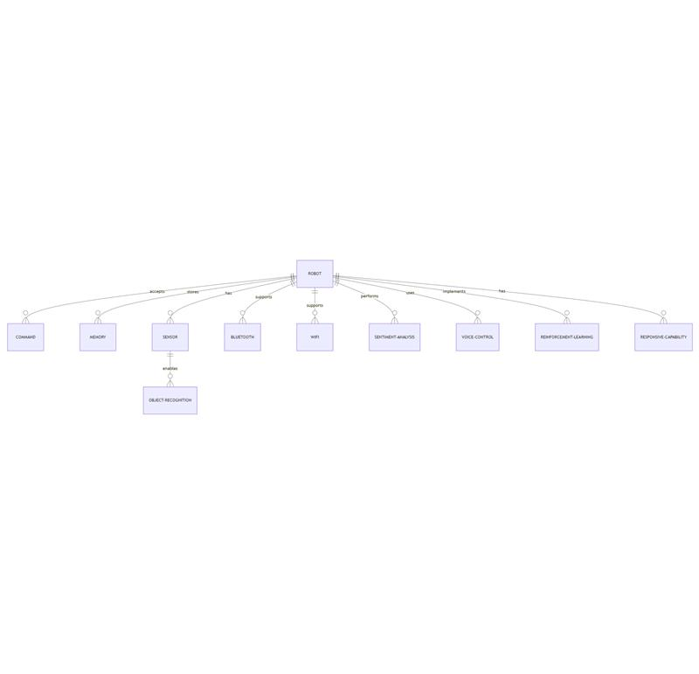

Chapter 3: Problem Statement
Building a smart home ecosystem integrated into a robot that responds to voice commands and controls various household appliances presents numerous challenges. While the vision of a seamless, interactive system is compelling, there are technical, design, and operational obstacles that must be overcome to ensure that the system is functional, reliable, and user-friendly. This chapter will explore some of the key challenges we anticipate during the development of this smart home ecosystem.

3.1 Challenges in Building a Smart Home Ecosystem
The integration of voice commands, robot mobility, and appliance control requires careful consideration of several factors. These challenges range from ensuring the accuracy of voice recognition in diverse environments to dealing with hardware limitations and managing a wide array of interconnected devices. Below are the main challenges we expect to face during the development of the ecosystem.

3.1.1 Voice Recognition Accuracy
Challenge:
Accurate voice recognition is a critical aspect of this project, but it is often one of the most difficult problems to solve. The system must recognize and understand a wide variety of voice commands, which can be influenced by factors like background noise, accents, speech patterns, and even user-specific nuances.
Explanation:
In a home environment, there are many sources of noise—background conversations, television sounds, kitchen appliances, or music—making it hard for a voice recognition system to accurately discern the intended command. Furthermore, humans have different accents, dialects, and speaking speeds, which can cause further misinterpretation. For instance, a command like "turn on the lights" could be spoken at varying volumes and tones, and the robot must interpret it correctly regardless of these variances.
To address this, we may need to integrate advanced noise-canceling technologies and ensure that the voice recognition software can handle diverse speech patterns. However, improving accuracy in such environments may require extensive training of the system with various audio samples, which can increase both development time and cost.
Solution Considerations:
One potential solution is using a hybrid approach, where voice recognition can be processed both locally (on the Raspberry Pi) for common commands and externally (via cloud services) for more complex queries. This would allow the robot to respond quickly to commands in the home, while still providing sophisticated, context-aware functionality when required.

3.1.2 Connectivity Issues
Challenge:
For the robot to control home appliances like lights, thermostats, and music systems, stable and continuous internet connectivity is crucial, especially for cloud-based services like Spotify. However, connectivity can be unreliable, with interruptions due to network issues or limited coverage in certain areas of the house. The system must be resilient to these interruptions, either by having offline capabilities or by implementing systems that can handle intermittent connectivity.
Explanation:
Some tasks, like streaming music or querying information from an online service, require a constant internet connection. Without stable connectivity, these features could become unreliable or unusable. Moreover, different appliances may require access to specific protocols or cloud services to function, making it even more challenging to ensure consistent connectivity.
On the other hand, if we move toward an offline model, the robot must have a robust local processing system that can execute essential tasks without requiring constant access to the internet. This would include pre-programmed tasks, such as controlling lights, fans, or even local media players. However, creating a fully offline ecosystem requires powerful hardware and software that can run the system without relying on the cloud.
Solution Considerations:
To tackle connectivity issues, it might be beneficial to incorporate redundancy systems—for example, allowing the robot to operate in an offline mode for critical functions while still having cloud access when needed. Local voice recognition and appliance control can help mitigate the effects of temporary internet outages. Additionally, ensuring the robot has a reliable and adaptable network connection—whether through Wi-Fi or Ethernet—will be important in maintaining continuous functionality.

3.1.3 Interoperability
Challenge:
Integrating a wide range of smart home devices into a cohesive ecosystem presents the challenge of ensuring that devices from different manufacturers and with varying communication protocols can work together seamlessly. Many smart home appliances use different standards and APIs (Application Programming Interfaces), such as Zigbee, Z-Wave, or Wi-Fi, which may not be natively compatible with each other.
Explanation:
Smart home ecosystems often operate within proprietary ecosystems (e.g., Alexa, Google Assistant), but each device manufacturer may implement their devices differently. A light bulb from one manufacturer might work seamlessly with an Alexa-based system, but the same bulb may not interact correctly with another system. Moreover, different communication protocols can complicate the integration process. If the robot is to manage devices across multiple platforms, it must support these diverse standards and protocols.
To address this, a universal communication standard like the Matter protocol is an important consideration, as it allows for more consistent interoperability across various devices. However, integrating Matter and ensuring compatibility with legacy devices could be an expensive and technically complex task.
Solution Considerations:
Using open-source software that supports multiple smart home protocols (e.g., Home Assistant) could help in managing devices from different manufacturers. The robot must be equipped with the capability to work with multiple communication protocols, potentially via adapters or bridges that allow the robot to interface with a variety of systems. Developing a robust middleware layer to manage these communication differences can streamline the integration process.

3.1.4 Hardware Compatibility
Challenge:
Integrating various hardware components, such as sensors, motors, and communication devices, presents a challenge in terms of compatibility. The Raspberry Pi, which serves as the central control unit, must be able to interface properly with sensors, motors, and other peripherals. Additionally, each component needs to work harmoniously, without interference or errors.
Explanation:
While the Raspberry Pi is a versatile and affordable platform, it has limitations in terms of processing power, memory, and connectivity. Ensuring that the robot's hardware components (e.g., sensors for obstacle detection, motors for movement, cameras for vision) can communicate effectively with the Pi can be a complex task. There are potential issues related to hardware compatibility, such as power requirements, data transmission protocols, or physical connections.
Moreover, if the system requires additional modules (like a camera or microphone), these components need to be correctly integrated with the Raspberry Pi. Some peripherals may require additional drivers, firmware updates, or third-party libraries to function correctly, which can slow down development.
Solution Considerations:
Testing each hardware component individually and ensuring that it works reliably before integration will be essential. Additionally, creating a well-structured software layer that abstracts hardware interactions (e.g., via libraries) will simplify the integration process. Developing custom drivers for components that don't have built-in support for Raspberry Pi can also mitigate compatibility issues.

3.1.5 Cost of Implementation
Challenge:
Building an advanced, autonomous robot that can control home appliances via voice is not a trivial task and may incur significant costs. The cost of development depends on the choice of hardware, the number of devices the robot will control, and the complexity of the software required for proper integration.
Explanation:
High-end components, like advanced voice recognition software, specialized sensors, high-definition cameras, and long-lasting batteries, can significantly increase the cost of the project. Additionally, ensuring that the robot has offline capabilities or can operate with a full-featured ecosystem of smart devices will increase the need for more powerful processors and additional hardware.
Even the licensing fees for using proprietary APIs, like the ones for services such as Spotify, or the need for cloud-based services (for voice recognition or AI) can add up. Moreover, if physical devices are needed for offline functionalities, this could lead to higher costs for procuring and maintaining these devices.
Solution Considerations:
In order to keep costs manageable, it's important to strike a balance between premium and cost-effective solutions. For instance, relying on open-source software for some of the system's core functionality can reduce software costs. Additionally, using a modular approach to hardware integration allows for future upgrades without redoing the entire system. Careful selection of components and planning for scalability will help manage the overall cost of the implementation.

Chapter 4: Equipment
In this chapter, we will describe the critical equipment used in the design and operation of the robot. Each piece of hardware plays a vital role in enabling the robot to perform its various functions autonomously and interact with the user in a meaningful way. From controlling the robot’s movements to providing visual and audio feedback, these components are the building blocks that make the robot capable of serving as an intelligent home ecosystem hub.

4.1 Raspberry Pi 3 Model B
The Raspberry Pi 3 Model B is the heart of the robot, serving as its central processing unit. It runs the robot’s operating system and software stack, performing crucial tasks such as speech-to-text conversion, decision-making, and the control of connected devices. The Raspberry Pi features a quad-core ARM Cortex-A53 processor, 1GB of RAM, integrated Wi-Fi, and Bluetooth capabilities. These features allow the robot to communicate wirelessly, connect to the internet, and process complex tasks like natural language understanding, audio processing, and controlling the various sensors and motors within the system.
Role:
The Raspberry Pi 3 Model B acts as the main control board for the robot. It processes voice commands, runs machine learning models for voice recognition, and manages sensor data. Additionally, it controls the robot’s connected appliances, handles automation tasks, and ensures smooth interaction between hardware components like the motors and sensors. The GPIO pins on the Raspberry Pi also facilitate communication with various sensors and actuators, enabling the robot to navigate autonomously and perform tasks like turning on lights, adjusting the thermostat, or playing music.
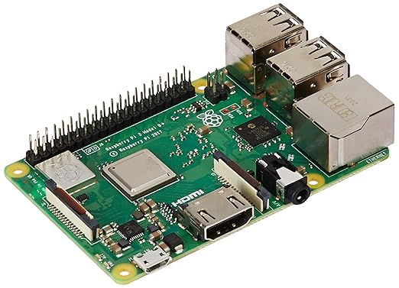

4.2 LCD Raspberry Pi 5 Inch Capacitive Touch Screen
The LCD Touchscreen provides the user interface for the robot, allowing users to interact with it in a visual and tactile manner. With a resolution of 800x480, this capacitive touchscreen offers responsive and intuitive control. The display will show important system information, status updates, available commands, and settings. Users can manually control certain aspects of the robot via this touchscreen interface, for example, adjusting volume, selecting functions, or reviewing system alerts.
Role:
The user interface aspect of the touchscreen provides a means for users to visually interact with the robot, especially in situations where voice control might not be ideal, such as when there is background noise or the robot's microphone does not capture the user's command. The touchscreen also enables users to quickly change settings, troubleshoot the system, or view diagnostics. It serves as an auxiliary control method in addition to voice recognition, ensuring that the robot remains versatile and user-friendly.

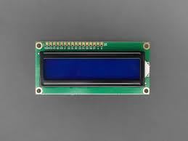

4.3 Talentcell YB1203000 Lithium-Ion Battery
The Talentcell YB1203000 is a lithium-ion battery designed to power the robot, ensuring it can operate independently of a fixed power source. This battery has a 12V, 3000mAh capacity, making it suitable for powering the robot’s components, such as the Raspberry Pi, sensors, motors, and other peripherals, during operation. A key benefit of this battery is its portability, allowing the robot to remain operational for a period of time without needing to be tethered to a power outlet.
Role:
The power supply role is crucial for maintaining the robot’s mobility and autonomy. The Talentcell battery will ensure that the robot can perform tasks in different areas of the home without needing to remain plugged into a wall socket. It enables the robot to operate for extended periods, performing functions such as navigation, voice interaction, and smart home control. Additionally, the battery will be used in conjunction with the robot’s charging system to ensure it recharges when not in active use.

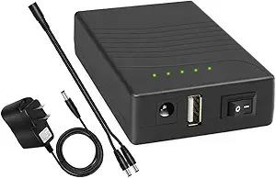

4.4 IR Sensor (TCRT5000)
The IR Sensor (TCRT5000) is an obstacle detection sensor used by the robot to navigate its environment. The TCRT5000 works by emitting infrared light and measuring the reflected light from objects in the robot's path. This allows the robot to detect nearby objects, walls, or obstacles that may impede its movement.
Role:
The IR sensor’s primary role is to assist with autonomous movement and navigation. It will help the robot detect and avoid obstacles, allowing it to navigate around furniture, walls, and other objects. This is critical for ensuring smooth and safe operation in dynamic environments. The IR sensor will be used when the robot is moving and must adjust its path in response to obstacles.
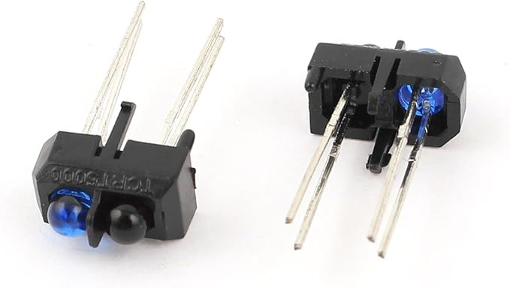

4.5 DC Motor (FT-46SGM370)
The DC Motor (FT-46SGM370) is responsible for providing the necessary mobility to the robot. This motor, with a 12V supply and a speed of 87 RPM, enables the robot to move across different surfaces. It will be responsible for driving the wheels or actuators that allow the robot to move forward, backward, or turn in place.
Role:
The motor will facilitate robot movement. It allows the robot to navigate through the environment, move between rooms, or travel to specific locations within the home to perform tasks. Whether it's responding to a user command to adjust the thermostat or physically moving to turn off a light, the motor will power the robot’s movements, allowing it to interact with its environment autonomously.


4.6 Speaker
The Speaker provides the audio output for the robot. It allows the robot to communicate with the user through verbal feedback, such as confirming actions or providing information. This speaker model (FRWS-5-8 Ohm) is designed to provide clear and crisp audio feedback, ensuring that the robot can effectively communicate with the user in a way that is understandable and natural.
Role:
The speaker’s primary role is to deliver voice feedback to the user. When a user gives a voice command, the robot will use the speaker to confirm the action or provide additional information (e.g., “Turning off the lights,” or “What would you like to play next?”). It is also used for issuing status updates and alerts, helping keep the user informed about the robot’s tasks and any required actions.

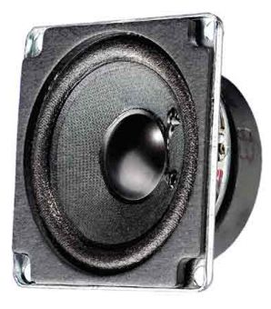

4.7 Camera (Raspberry Pi Camera Module 3)
The Raspberry Pi Camera Module 3 captures visual input, enabling the robot to "see" its environment. The camera is used for various purposes, including object recognition, navigation, and facial recognition. By processing the images it captures, the robot can understand its surroundings, detect specific objects, or recognize users based on their facial features.
Role:
The camera is used for recognition and interaction. For example, the robot can use facial recognition to identify users and respond with personalized greetings or actions. It can also be used for environment mapping and obstacle detection, helping the robot to adjust its movement based on the objects in its path. The camera will be an essential component for more advanced interactions, such as security monitoring and object recognition.
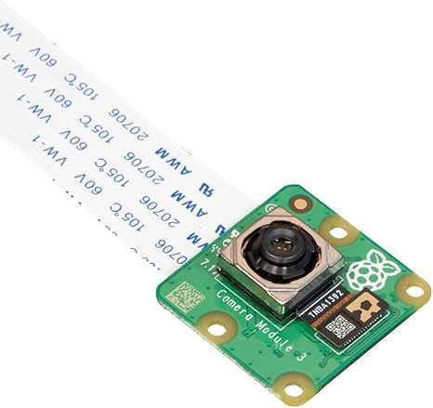

4.8 Microphone (GY-MAX4466 Electret Microphone)
The Microphone is used for audio input, capturing sound waves from the environment, including the user’s voice. This microphone will be a key component in enabling voice recognition and communication. It will pick up the user's voice commands, which are then processed by the Raspberry Pi for action.
Role:
The microphone’s primary role is to capture voice input for voice recognition. The robot will continuously listen for specific keywords or commands, such as “Turn on the lights” or “Play music.” Once the microphone captures the audio, it will be converted into a digital signal and passed to the processing unit (Raspberry Pi) for interpretation and response.

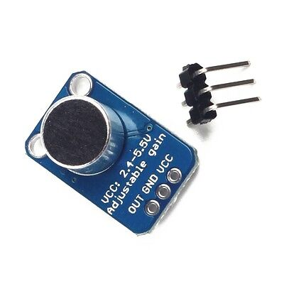

4.9 USB C and USB A Modules
The USB C and USB A Modules provide the necessary connectivity for the robot. These modules allow for data transfer and connection to peripheral devices such as USB storage, external sensors, or network adapters.
Role:
The USB modules will be used for expanding connectivity. They allow for easy integration of additional peripherals that may be required as the system evolves, such as external hard drives for storage, USB microphones, or even custom modules designed for specific tasks.

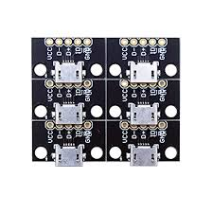

4.10 Push Button
The Push Button serves as a manual override for certain functions of the robot. If the robot is unresponsive or requires a reset, the button can be used to restart or reboot the system. This can be helpful in troubleshooting or when the robot needs to be manually engaged by the user.
Role:
The push button offers manual interaction with the robot. It ensures that users can control the system even if voice commands or touchscreen input are unavailable. It can also serve as a reset mechanism, providing a way to restart the robot or recover from an error state.

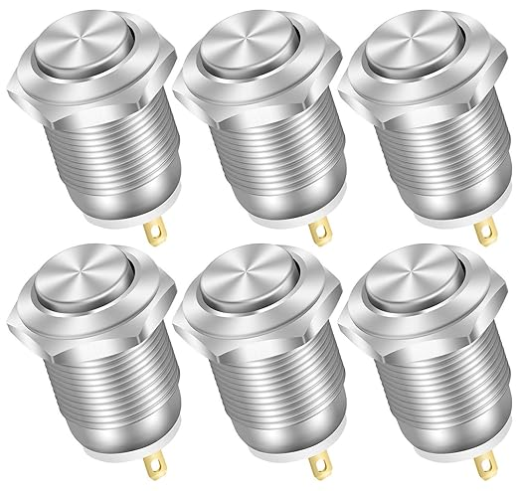

4.11 Magnet
The Magnet will be used in the robot for physical interaction, such as securing components in place or triggering specific actions. For example, the magnet could be used to hold sensors or cameras in place, or to detect specific triggers or conditions based on magnetic fields.
Role:
The magnet's role in the system is primarily to support physical interaction. It could also serve in specific sensor-based actions, such as detecting the presence of metal objects or activating specific sensors in the robot.



Chapter 5: Equipment Usage
In this chapter, we will describe the key components of the robotic system, detailing how each piece of equipment will be utilized, when it will be used, and for which specific tasks. These components, ranging from the central processing unit to sensors and power supplies, form the backbone of the robot's functionality. A well-integrated system will enable the robot to efficiently interact with its environment and provide valuable services for the home ecosystem.

5.1 Main Control: Raspberry Pi 3 Model B
The Raspberry Pi 3 Model B will act as the central control unit for the robot. This small but powerful single-board computer will be responsible for running all the software necessary for voice recognition, interaction, and appliance control. It will also handle communication between various components of the system, such as the microphone, speakers, LCD touchscreen, and sensors, ensuring they all work in harmony.
Why We Will Use It:
The Raspberry Pi 3 Model B is an ideal choice because it offers a balance between performance and cost, with the capability to support complex operations like voice recognition and running the robot’s core algorithms. Its 1.2 GHz quad-core ARM Cortex-A53 processor and 1GB of RAM make it capable of handling basic processing tasks, including natural language processing (NLP) for voice commands. Additionally, the Raspberry Pi is widely used in the maker and robotics communities, meaning there is a wealth of software and hardware resources available for development, reducing time to market.
When We Will Use It:
The Raspberry Pi 3 Model B will be in constant operation, serving as the brain of the robot. Upon receiving power, it will boot up and start running the robot’s operating system and software stack. It will be used continuously during operation, processing voice commands, controlling devices, managing communication between different components (such as the camera and sensors), and handling the robot’s logic for actions like playing music, turning lights on or off, or adjusting the thermostat.
For Which Work:
The Raspberry Pi will perform the following critical tasks:
- Voice Recognition: It will process spoken commands received from the user via the microphone and send them to the appropriate application or module (e.g., controlling lights or playing music).
- Communication: It will manage communication with external devices, such as smart appliances or internet services (like the Matter API for controlling smart devices).
- Data Handling: The Pi will store and manage user preferences, task history, and configuration settings, allowing the robot to provide personalized services.
- Software Integration: It will run various software frameworks (e.g., OpenCV for vision processing, TensorFlow for AI, and voice recognition libraries like Google Speech API or Rhasspy) that enable the robot to operate autonomously.

5.2 User Interface: LCD Touchscreen
The LCD Touchscreen will provide a user-friendly interface for manually interacting with the robot. While voice control will be the primary method of interaction, the touchscreen will serve as an auxiliary input method, allowing users to adjust settings, review status updates, or troubleshoot if needed. The screen will display vital information such as system status, available commands, and device settings.
Why We Will Use It:
The LCD touchscreen is crucial for offering a tactile interface in addition to the voice-based system. While voice commands will cover most of the daily interactions, there are instances where users may prefer to use visual control. It can also serve as a backup for situations where the voice recognition may not be accurate due to background noise, or the user simply prefers using the screen for certain tasks.
When We Will Use It:
The touchscreen will be used when:
- Manual Control: The user wants to manually control or adjust settings that might not be easily done through voice commands (e.g., changing screen brightness, adjusting volume, etc.).
- Status Monitoring: When the user needs to quickly check the current status of devices or the robot itself, such as whether the lights are on, the current temperature, or any updates related to the system’s health.
- Interaction & Troubleshooting: In situations where voice commands fail or the user needs more detailed control, the touchscreen will serve as a visual interface for troubleshooting and configuration.
For Which Work:
The touchscreen will be primarily used for:
- Displaying Feedback: It will show real-time feedback from the robot, such as "Listening," "Executing," or "Waiting for Command," ensuring the user is always informed.
- User Configuration: The touchscreen will allow users to configure preferences, like changing the robot's voice settings or setting up automation rules for smart devices.
- Manual Device Control: If the user wants to adjust something on the robot or connected appliances directly, the touchscreen will provide an easy interface to do so. For example, adjusting volume for the speaker or changing the Wi-Fi settings.

5.3 Power Supply: Talentcell YB1203000
The Talentcell YB1203000 is a lithium-ion battery pack that will power the robot when it is not connected to mains power. The battery is essential for providing mobility and autonomy to the robot, allowing it to function independently for a period of time. It is designed to work with 12V devices and comes with a USB interface for charging or powering devices.
Why We Will Use It:
The Talentcell YB1203000 battery is a high-capacity, portable power supply that is perfect for mobile robots. The capacity of 12,000mAh ensures that the robot can function for several hours, depending on the power demands of its components. This is particularly useful in scenarios where the robot needs to be mobile, such as when it is roaming around the house to assist with tasks like light control, security monitoring, or even interacting with the user in different rooms.
When We Will Use It:
The battery will be in use whenever the robot is not connected to the mains power supply. This will typically be during periods when the robot needs to move around the house or perform tasks autonomously. The battery will power the robot's internal components, including the Raspberry Pi, sensors, speakers, and touchscreen. Additionally, it will be used in conjunction with the robot’s charging base to ensure that the robot can recharge automatically when not in use.
For Which Work:
The Talentcell YB1203000 will supply power to the following:
- Central Control (Raspberry Pi 3): The primary control unit will run entirely off the battery when mobile.
- Sensors and Cameras: These components, including the IR sensors and camera, will require power from the battery to function.
- Speakers and Microphone: Voice communication and sound feedback will be powered by the battery.
- Touchscreen Display: The screen will also be powered by the battery to ensure the user interface remains functional while on the move.

5.4 Voice and Audio: Speaker and Microphone
The Speaker and Microphone system will facilitate two-way communication between the user and the robot. The microphone will pick up voice commands, while the speaker will play responses and feedback from the robot. Together, these components enable the robot to understand and respond to user instructions, as well as convey its own status and alerts.
Why We Will Use It:
The voice interaction system is critical for the robot’s role in the smart home ecosystem. Users expect a seamless, hands-free experience when interacting with the robot, and the microphone and speaker setup ensures that the robot can hear and respond to commands in a natural and intuitive way. The microphone will also be responsible for gathering audio input during voice recognition, while the speaker will allow the robot to verbally respond to commands and feedback.
When We Will Use It:
The speaker and microphone will be used continuously during operation. The microphone will always be active to listen for commands, while the speaker will be used whenever the robot needs to communicate back to the user. This will happen whenever a voice command is issued, or when the robot provides verbal feedback on its current status or actions. For example, when a user says, “Turn on the lights,” the microphone will capture the command, and the speaker will confirm, saying, “Turning on the lights.”
For Which Work:
The microphone and speaker will be involved in the following tasks:
- Voice Command Recognition: The microphone will capture voice commands from the user and send them to the Raspberry Pi for processing.
- Speech Feedback: The speaker will be used to provide audio feedback, such as confirming actions or offering status updates (“Lights are on,” “Playing your music,” etc.).
- Interactive Communication: For more complex interactions, such as asking the robot for information or guidance, the speaker will facilitate a natural dialogue.

5.5 Sensors: IR Sensor and Camera
The IR Sensor and Camera are key components for enabling the robot to perceive and navigate its environment. The IR sensor will help the robot detect obstacles and avoid collisions, while the camera will be used for advanced tasks like object detection and facial recognition.
Why We Will Use It:
Sensors like the IR sensor and camera provide the robot with environmental awareness. These components allow the robot to navigate the house autonomously and perform tasks that require vision, such as recognizing faces or detecting movement. They also help the robot make intelligent decisions about when to move, stop, or interact with specific objects.
When We Will Use It:
The IR sensor will be active whenever the robot is moving to ensure it avoids obstacles in its path. The camera will be used when the robot needs to identify specific objects, people, or areas in the house. This could include recognizing a user’s face to trigger personalized responses, detecting movement to ensure security, or scanning the environment for hazards.
For Which Work:
- Obstacle Avoidance: The IR sensor will help the robot navigate its environment by detecting obstacles and adjusting its movement accordingly.
- Face Recognition: The camera will be used to recognize the faces of users or visitors, allowing the robot to provide a personalized experience based on who it detects.
- Object Detection: The camera will also be useful for tasks like detecting whether a device (like a light or TV) is on, or monitoring specific areas for security purposes.

Chapter 6: Approach and Features

6.1 Feature Approach
In this section, we will explore different approaches to the features of the robotic system. These approaches range from premium solutions, which offer the highest quality and most advanced capabilities, to more cost-effective, but still functional, solutions.

6.1.1 Face Animation Approach

Approach 1: Premium – OpenGL (High-Cost, High-Quality)
Description:
OpenGL is a widely used graphics library for rendering 2D and 3D graphics, offering full control over how animations, textures, and facial features are rendered. Using OpenGL for face animation allows for high-quality, real-time, dynamic facial expressions, making the robot’s face appear as lifelike and interactive as possible.
Pros:
- High Customization: The robot’s face can be fully customized, allowing for unique and expressive features that can change depending on the robot's interactions.
- Real-Time Processing: Can handle complex animations in real time, which is perfect for interactive scenarios.
- Visual Quality: The highest quality visuals, suitable for premium products that require the most advanced user experience.
Cons:
- High Cost: Requires advanced hardware (e.g., high-end GPUs) to render real-time animations, increasing the system's cost. Additionally, the development process is time-consuming and requires specialized knowledge in computer graphics.
- Resource-Intensive: Demands significant computational power, which could affect the robot's overall performance and increase energy consumption.
Cause for Cost:
The specialized graphics programming involved in creating OpenGL-based face animations demands skilled developers, extensive development time, and hardware capable of rendering high-quality visuals in real-time, making it a premium solution.

Approach 2: Medium – Model Download (Mid-Cost, Balanced Quality)
Description:
Instead of developing animations from scratch, this approach utilizes pre-existing 3D facial models and animation systems that are available for download. These models can be adjusted to suit the robot's specifications and offer a more cost-effective way to achieve realistic facial animations.
Pros:
- Faster Development: Pre-made models drastically reduce development time.
- Moderate Customization: While not as flexible as OpenGL, there is still room to customize the face, but within the limitations of the model itself.
- Balanced Quality: Still provides realistic animations without the heavy resource requirements of OpenGL.
Cons:
- Limited Control: The degree of customization is limited to what the downloaded models allow.
- Mediocre Visual Fidelity: While the animations are realistic, they may not achieve the same level of fluidity or expressiveness as OpenGL-based custom animations.
Cause for Cost:
This approach is cost-effective as it leverages pre-built resources. However, the customization options are not as extensive, which makes it a middle-ground solution in terms of cost and quality.

Approach 3: Normal – Stable Diffusion Model (Low-Cost, Highly Customizable)
Description:
Stable Diffusion, a generative AI model, can be used to create dynamic facial animations by generating images in real-time based on input prompts. It can simulate lifelike facial expressions by training the model on a dataset of images. While not a traditional method for animation, it provides flexibility and creativity in generating unique faces.
Pros:
- Highly Customizable: Offers flexibility by generating new, unique faces and expressions, potentially allowing for greater creativity.
- Low Cost: It relies on software rather than expensive hardware, making it more affordable.
- Custom Animations: Can generate various facial expressions based on situational context.
Cons:
- Computational Limitations: Though less costly, Stable Diffusion requires substantial processing power for generating high-quality animations.
- Visual Fidelity: While good, the visual fidelity may not reach the level of OpenGL, especially for real-time animations. The transitions between facial expressions may not appear as smooth.
Cause for Cost:
While Stable Diffusion requires less specialized hardware compared to OpenGL, it still involves significant computation to generate high-quality images. However, it is a highly flexible and cost-effective solution for generating animations without the need for complex manual programming.

6.1.2 Online Connectivity

Approach 1: Premium – OpenAI (High-Cost, Advanced AI)
Description:
OpenAI offers advanced voice recognition and natural language processing capabilities, such as GPT-based models, which can interpret and generate human-like responses. By using OpenAI for connectivity, the robot can have deep conversational abilities, with understanding of context, sentiment, and intent.
Pros:
- Highly Accurate NLP: Capable of understanding complex commands and conversations.
- Human-Like Interactions: Offers natural, fluid conversations, making the robot seem more intelligent and responsive.
- Scalability: OpenAI’s cloud infrastructure supports massive amounts of data, making it scalable for large projects.
Cons:
- High Cost: The usage of OpenAI’s API comes with a cost, particularly if the system requires heavy processing or real-time data processing.
- Dependency on Internet: Requires a continuous internet connection, and the cost can rise with higher usage or need for low-latency responses.
Cause for Cost:
OpenAI's models are state-of-the-art, which ensures top-quality results in voice interaction and understanding. However, this comes at a premium due to the advanced AI models and cloud-based infrastructure.

Approach 2: Medium – Gemini (Mid-Cost, Reliable AI)
Description:
Gemini, a powerful AI developed by Google, provides robust language processing capabilities, especially for tasks like voice recognition, command interpretation, and contextual responses. It can be integrated into the robot to interpret and process commands efficiently.
Pros:
- High Accuracy: Gemini provides accurate results, capable of handling various languages, accents, and different speaking styles.
- Cost-Effective: Compared to OpenAI, Gemini offers a more affordable solution, especially in terms of pricing per usage.
- Scalable: Can support multiple concurrent interactions without compromising performance.
Cons:
- Moderate Flexibility: While capable, it may not be as adaptable or nuanced as OpenAI for certain complex interactions.
- Requires Internet: Like OpenAI, Gemini depends on an internet connection to function effectively.
Cause for Cost:
Gemini offers a solid balance between cost and performance. It provides an effective solution for high-quality voice processing without the high price tag of premium solutions.

Approach 3: Normal – Grok (Low-Cost, Basic AI)
Description:
Grok is an AI service designed for more cost-effective solutions. While it may not provide the same level of sophistication as OpenAI or Gemini, it is capable of understanding and processing basic commands and executing common tasks effectively.
Pros:
- Affordable: The most cost-effective solution for basic voice recognition and command processing.
- Easy Integration: Simple to implement with minimal setup, making it ideal for less complex systems.
- Good for Basic Tasks: Handles standard voice commands like "turn on the lights" or "play music."
Cons:
- Limited Understanding: Does not have the same depth of understanding or conversational ability as more advanced AI options.
- Less Context-Aware: Grok may struggle with more complex interactions or ambiguous commands.
Cause for Cost:
The low cost comes from Grok’s focus on basic voice recognition tasks. While not suitable for advanced conversations, it provides a functional solution for simpler use cases at a fraction of the price.

6.1.3 Offline Functionality

Approach 1: Premium – Llama (High-Cost, Advanced Offline AI)
Description:
Llama is an advanced AI model capable of running locally on devices, offering highly accurate and efficient voice recognition and processing without the need for an internet connection. However, implementing Llama requires significant computational resources and physical hardware to support its operations.
Pros:
- Offline Functionality: Does not rely on internet connectivity, ensuring the robot remains operational even in environments with no access to the cloud.
- High Accuracy: Provides top-tier AI processing for voice commands, offering highly accurate recognition and execution of tasks.
Cons:
- High Cost: Setting up Llama requires powerful local hardware, which significantly increases costs for both hardware and energy consumption.
- Complex Setup: Requires significant development and hardware resources to implement.
Cause for Cost:
Llama requires specialized hardware capable of running complex models locally, as well as the development of custom solutions to handle local AI processing, making it the most expensive offline solution.

Approach 2: Medium – Edge AI (Mid-Cost, Reliable Offline AI)
Description:
Edge AI solutions allow for localized processing of voice commands and responses. These systems use smaller, optimized models that can be run on devices like the Raspberry Pi, providing offline functionality without requiring large amounts of computational power.
Pros:
- Offline Operation: Works without the need for a constant internet connection, ensuring reliability in any environment.
- Cost-Effective: More affordable than running full-scale models like Llama, making it suitable for medium-scale applications.
Cons:
- Lower Accuracy: While still reliable, edge AI models may not offer the same level of accuracy or understanding as their cloud-based counterparts.
- Limited Scope: Generally limited to simpler tasks and commands, although this can be expanded with optimized models.
Cause for Cost:
Edge AI offers a reasonable compromise between cost and functionality, with sufficient processing power for offline voice recognition but without the need for expensive hardware.

Approach 3: Normal – Offline Open-Source AI Models (Low-Cost, Basic Offline AI)
Description:
Using open-source AI models (such as Rasa or Mycroft) allows for offline functionality at a much lower cost. These models are customizable and can run on basic hardware like a Raspberry Pi, making them ideal for budget-conscious implementations.
Pros:
- Low Cost: The cheapest solution for offline voice recognition, as these models are open-source and free to use.
- Customizable: Open-source AI models can be adapted to fit specific needs, allowing for a tailored experience.
- No Internet Required: Fully offline, ensuring functionality in remote areas.
Cons:
- Limited Features: Open-source models often lack the depth and sophistication of paid services.
- Requires Development: Needs customization and integration work to ensure it functions as needed.
Cause for Cost:
The low cost of open-source models comes from the lack of licensing fees, but they still require considerable development and may not offer the advanced capabilities of premium solutions.

6.2 Main Goal: Home Ecosystem Documentation
The ultimate goal of this project is to develop an intelligent home ecosystem that extends beyond the capabilities of existing voice-controlled assistants like Google Assistant or Alexa, introducing a more interactive and autonomous robotic interface. This robot will serve as a central hub for controlling various home appliances and devices through natural voice commands. It will not only allow the user to control lighting, heating, entertainment systems, and other smart home appliances, but will also be capable of responding to personalized commands, understanding context, and providing a more human-like, intuitive interaction.
This vision is inspired by the rapid growth in home automation technologies, where many devices now come with the capability to connect and interact via the internet. However, most systems still rely on multiple separate devices (e.g., smart speakers, mobile apps) that require the user to interact with each one individually. The concept here is to create an ecosystem where a single robot can serve as the interface for all these devices. This system aims to bring home automation to the next level by integrating voice control, physical interaction, and intelligent decision-making in a robotic form, creating an immersive experience for the user.
The home ecosystem envisioned here will be robust, flexible, and easily scalable, supporting various devices from different manufacturers. This system will integrate with existing technologies, leveraging the Matter API, a unified standard for smart home devices that ensures interoperability across a wide range of brands and platforms.

6.2.1 Overview of the Home Ecosystem
At its core, the home ecosystem consists of several major components that work in unison to provide a seamless and interactive smart home experience:
- Robotic Interface: The robot itself serves as the central control unit, integrating all the devices and offering voice control, monitoring, and feedback. The robot’s physical presence allows for a more engaging interaction compared to traditional smart speakers. It will be equipped with advanced sensors, cameras, microphones, and speakers, enabling it to recognize users, respond to voice commands, and communicate with smart home appliances.
- Voice Control: One of the primary features of the ecosystem is the ability to control devices using natural language voice commands. Users can issue commands like “turn on the lights,” “play music,” or “adjust the thermostat,” and the robot will process the command and take the necessary actions. The system will rely on state-of-the-art voice recognition and natural language processing (NLP) models to ensure accurate command interpretation, even in noisy environments or with diverse accents.
- Smart Home Devices: The ecosystem will integrate a wide variety of smart devices, including lighting, thermostats, TVs, sound systems, security cameras, and more. These devices can be controlled through the robot using voice commands or via a companion app. Integration with the Matter API will ensure that the ecosystem is compatible with a wide range of smart devices from different manufacturers, promoting interoperability and flexibility.
- Connectivity Layer: The robot will connect to various smart home appliances either directly via Wi-Fi, Bluetooth, Zigbee, or other communication protocols. For devices that support internet-based control, the robot will communicate via the Matter API, which ensures compatibility across different ecosystems and brands. Matter, developed by the Connectivity Standards Alliance (CSA), aims to solve the problem of fragmentation in the smart home market by providing a unified platform for controlling devices.
- Autonomous Operation: Beyond simple voice commands, the robot will be capable of autonomous actions based on environmental data, context, and user behavior. For example, it could automatically adjust the lighting based on the time of day, play music when the user enters the room, or switch off unused devices to save energy. These autonomous features will make the system more intelligent, proactive, and adaptable to the user’s lifestyle.

6.2.2 Matter API and Cross-Compatibility
One of the main challenges in the smart home industry is the fragmentation of ecosystems, with different manufacturers using their proprietary technologies to connect and control their devices. This leads to compatibility issues, making it difficult for users to integrate devices from different brands into a single cohesive system. The Matter API is a game-changer in this regard, as it provides a unified standard for smart home devices, ensuring that they can communicate and work together seamlessly.
The integration of the Matter API into our home ecosystem will provide several key benefits:
- Interoperability: Matter enables devices from different manufacturers to work together in the same ecosystem. Whether it’s a smart light from Philips Hue, a smart thermostat from Nest, or a speaker from Sonos, the Matter API will ensure that these devices can be controlled through a single interface – the robot.
- Scalability: As new smart devices continue to enter the market, integrating them into the ecosystem will be straightforward, as they will simply need to support the Matter standard. This makes the system highly scalable and adaptable to future innovations in smart home technology.
- Simplified User Experience: By relying on the Matter standard, the robot can offer a consistent and reliable user experience. Users won’t need to worry about whether their devices are compatible with their smart assistant or require additional bridges or hubs for integration. Everything will work seamlessly together, whether the robot is controlling lights, blinds, security cameras, or entertainment systems.
- Security: Matter places a strong emphasis on security, ensuring that communication between devices is encrypted and that user data is protected. This will help address privacy concerns that many users have when integrating smart devices into their homes.
By adopting Matter, our ecosystem will be future-proofed, providing users with a reliable and interoperable solution that can grow with the rapidly changing smart home landscape.

6.2.3 Voice-Driven Interaction and Automation
Voice control is at the heart of the system, allowing users to interact with their home appliances in a more natural and intuitive manner. However, the integration of voice control goes beyond just recognizing commands – it will also involve:
- Context-Aware Responses: The robot will be able to understand the context of the interaction and provide relevant responses. For example, if the user asks, “What’s the temperature like today?”, the robot will not only provide the current temperature but may also offer to adjust the thermostat or suggest a setting that would make the environment more comfortable.
- Personalization: The system will learn the user’s preferences over time. For example, if the user frequently adjusts the lights to a specific setting in the evening, the robot could proactively set the lights to that preference when it detects the user’s presence in the room. This level of personalization will create a more engaging and intelligent home environment, reducing the need for manual intervention.
- Routine Automation: The robot will enable users to create custom routines that automate everyday tasks. For instance, a user could set up a routine that turns off the lights, locks the doors, and adjusts the thermostat when they say “Goodnight.” The robot will also be able to suggest routines based on user behavior, optimizing home energy consumption, security, and comfort.
- Multimodal Feedback: While voice will be the primary interface, the robot will also use visual feedback to communicate with users. The LCD touchscreen and facial animations will provide additional layers of interaction, giving the robot a more human-like presence. The robot can show visual status updates, express emotions, or respond to commands with a combination of speech and visual cues.

6.2.4 Autonomous Behavior and Energy Efficiency
One of the key features of this intelligent ecosystem is its ability to act autonomously based on various factors such as time of day, user behavior, and environmental conditions. This includes:
- Proactive Device Control: The robot can autonomously manage devices to optimize comfort and energy usage. For example, it could adjust the thermostat based on the temperature outside or turn off lights when it detects that no one is in the room.
- Smart Scheduling: The robot can automate tasks like turning off unused devices, adjusting heating or cooling settings, or running appliances at off-peak hours to save energy. This contributes to energy efficiency and can lower the overall household utility costs.
Adaptability: Over time, the robot will learn the user’s patterns and adapt its behavior accordingly. For instance, if the user constantly asks the robot to play music at a particular time of day, the robot can proactively initiate the music at that time without needing a command.

6.2.5 Future Scalability and Growth
As new technologies emerge in the smart home market, the system will be built with scalability in mind. The Matter API provides a future-proof solution by ensuring that new devices are easily added to the ecosystem. Moreover, the robot can evolve as new features are developed, integrating with emerging technologies like 5G, AI-powered assistants, and edge computing for more localized processing.

